|  |
| --- |
| **موضوع تحقیق** : چند سوال **تاریخ** : 24/07/1404 |
| **استاد راهنما**  : دکتر سجاد فرخی |
| **گرد آورنده**  : علیرضا کاروی |

**در رابطه با زاویه در طیف فوریه تحقیق کنید**

**زاویه ای که در خروجی تبدیل فوریه بدست می اید. زاویه و فاز تبدیل فوریه چه اطلاعاتی به ما می دهد ؟**

………………………………………………………………………………………………………………………………………………………………………………………………………………………………………………………………………………………………………………………………………………………………………………………………………………………………………………………………………………………………………………………………………………………………………………………………………………………………………………………………………………………………………………………………………………………………………………………………………………………………………………………………………………………………………………………………………………………………………………………………………………………………………………………………………………………………………………………………………………………………………………………………………………………………………………………………………………………………………………………………………………………………………………………………………………………………………………………………………………………………………………………………………………………………………………………………………………………………………………………………………………………………………………………………………………

………………………………………………………………………………………………………………

**در رابطه با properties FFT 2D تحقیق**………………………………………………………………………………………………………………………………………………………………………………………………………………………………………………………………………………………………………………………………………………………………………………………………………………………………………………………………………………………………………………………………………………………………………………………………………………………………………………………………………………………………………………………………………………………………………………………………………………………………………………………………………………………………………………………………………………………………………………………………………………………………………………………………………………………………………………………………………………………………………………………………………………………………………………………………………………………………………………………………………………………………………………………………………………………………………………………………………………………………………………

**مستطیل فرکانسی چطور انجام میشود**

**نحوه چینش FFT shift در حالت دو بعدی چطور انجام می شود؟**

………………………………………………………………………………………………………………………………………………………………………………………………………………………………………………………………………………………………………………………………………………………………………………………………………………………………………………………………………………………………………………………………………………………………………………………………………………………………………………………………………………………………………………………………………………………………………………………………………………………………………………………………………………………………………………………………………………………………………………………………………………………………………………………………………………………………………………………………………………………………………………………………………………………………………………………………………………………………………………………………………………………………………………………………………………………………………………………………………………………………………………………………………………………………………………………………………………………………………………………………………………………………………………………………………………

………………………………………………………………………………………………………………

**بررسی نتیجه متلب تست 3**

clc

clear

close all

[x,y]=meshgrid(-128:217,-128:127);

z=sqrt(x.^2+y.^2);

c=(z<15);% Circule

cf=fftshift(fft2(double(c)));

%% Show results

set(gcf,'units','normalized','outerposition',[0 0 1 1])

subplot(1,2,1),imshow(c),title('Original Image');

subplot(1,2,2),fftshow(cf,'log'),title('Specturum of Image');

………………………………………………………………………………………………………………………………………………………………………………………………………………………………………………………………………………………………………………………………………………………………………………………………………………………………………………………………………………………………………………………………………………………………………………………………………………………………………………………………………………………………………………………………………………………………………………………………………………………………………………………………………………………………………………………………………………………………………………………………………………………………………………………………………………………………………………………………………………………………………………………………………………………………………………………………………………………………………………………………………………………………………………………………

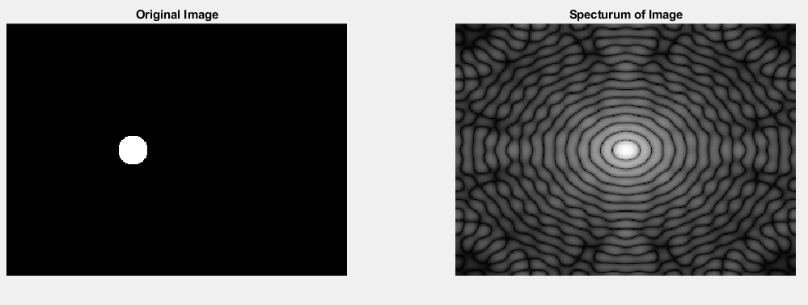

**بررسی نتیجه متلب تست 4**

clc

clear all

close all

[x,y]=meshgrid(-128:217,-128:127);

z=sqrt(x.^2+y.^2);

c=(z<15);% Circule

cf=fftshift(fft2(double(c)));

%% Show results

set(gcf,'units','normalized','outerposition',[0 0 1 1])

subplot(1,2,1),surf(double(c(1:5:end,1:5:end))),title('Original Image');

subplot(1,2,2),fftshow(cf,'log'),title('Specturum of Image');

………………………………………………………………………………………………………………………………………………………………………………………………………………………………………………………………………………………………………………………………………………………………………………………………………………………………………………………………………………………………………………………………………………………………………………………………………………………………………………………………………………………………………………………………………………………………………………………………………………………………………………………………………………………………………………………………………………………………………………………………………………………………………………………………………………………………………………………………………………………………………………………………………………………………………………………………………………………………………………………………

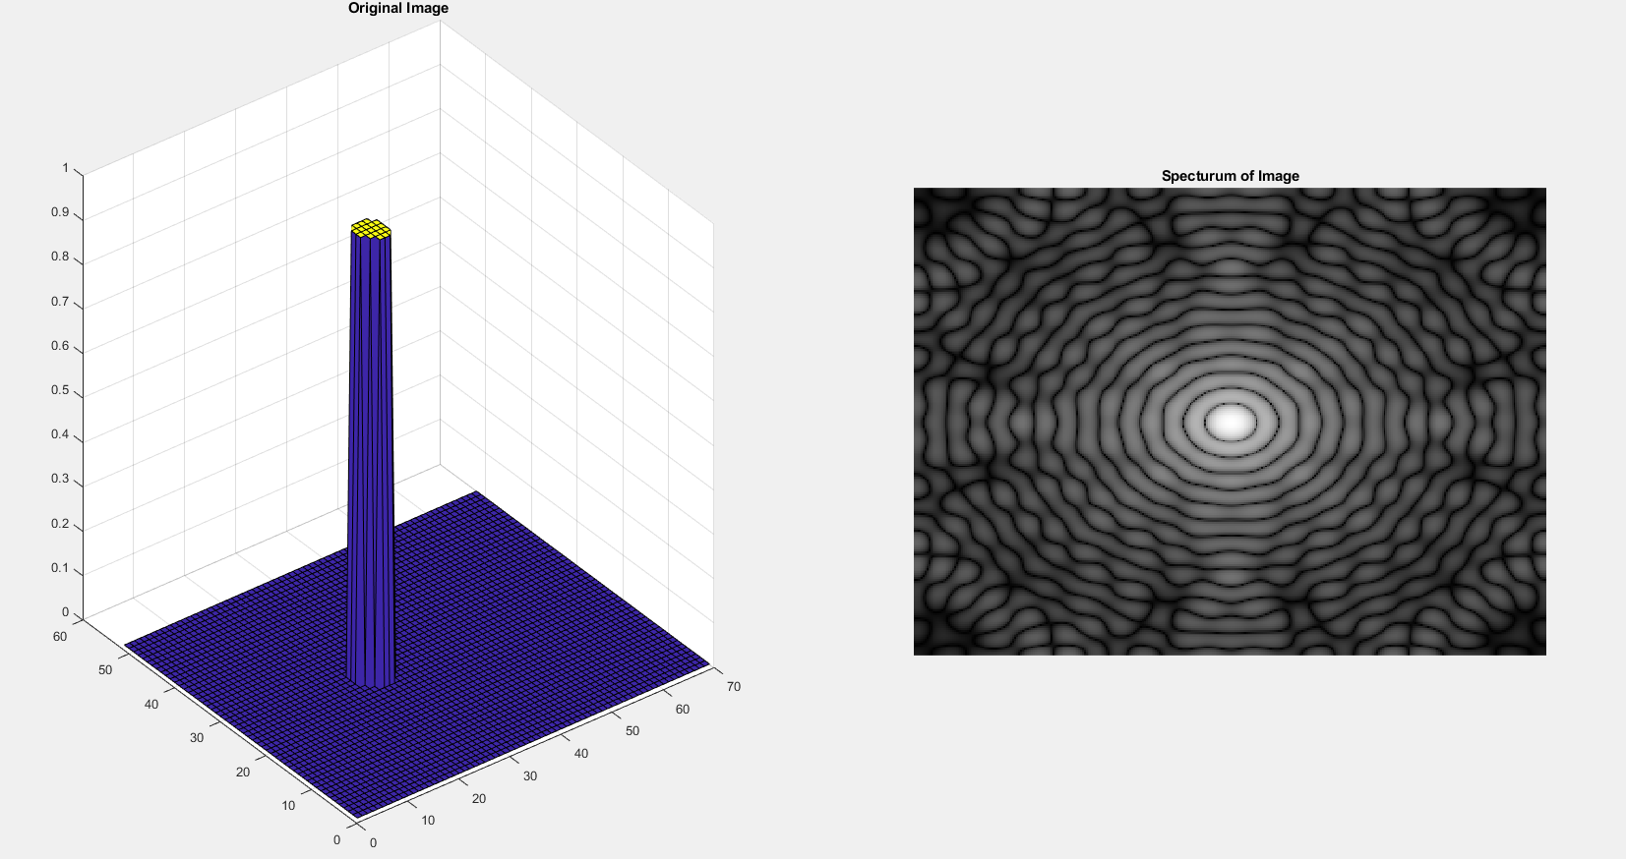

**بررسی نتیجه متلب تست 4ـ0**

clc

clear

close all

[x,y]=meshgrid(-128:217,-128:127);

z=sqrt(x.^2+y.^2);

c=1./(1+(z./15).^2);

cf=fftshift(fft2(double(c)));

%% Show results

set(gcf,'units','normalized','outerposition',[0 0 1 1])

subplot(1,2,1),surf(double(c(1:5:end,1:5:end))),title('Original Image');

subplot(1,2,2),fftshow(cf,'log'),title('Specturum of Image');

………………………………………………………………………………………………………………………………………………………………………………………………………………………………………………………………………………………………………………………………………………………………………………………………………………………………………………………………………………………………………………………………………………………………………………………………………………………………………………………………………………………………………………………………………………………………………………………………………………………………………………………………………………………………………………………………………………………………………………………………………………………………………………………………………………………………………………………………………………………………………………………………………………………………………………………………………………………………………………………………………………………………………………………………

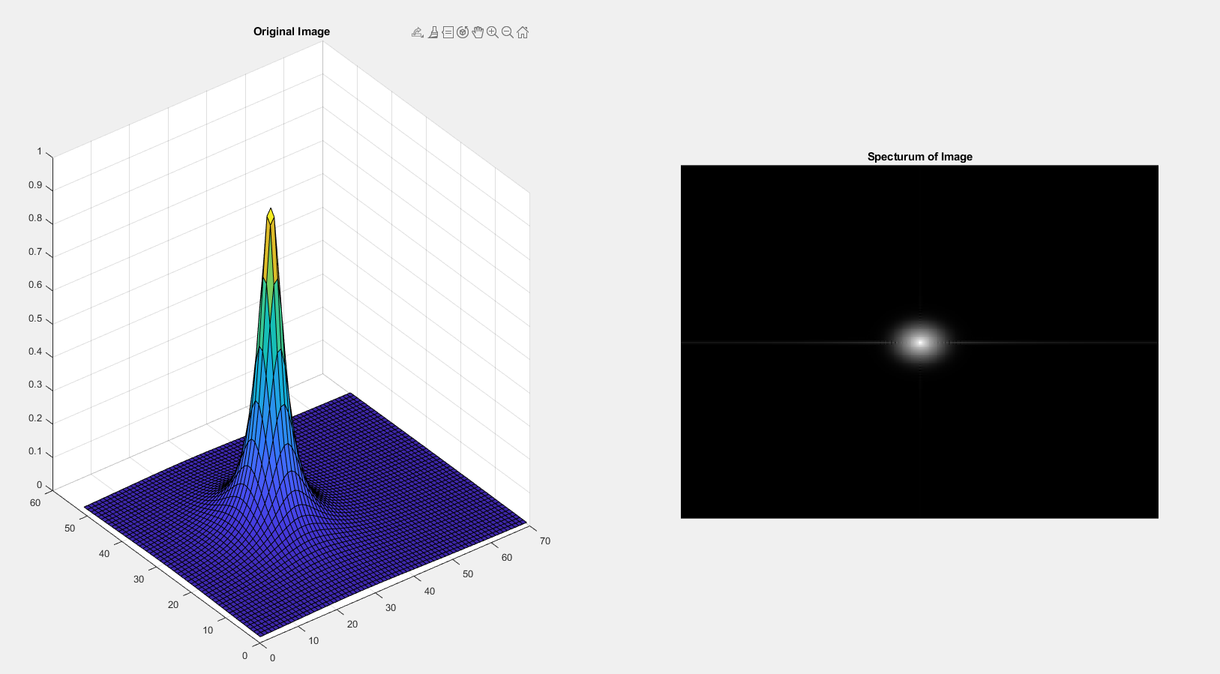

**بررسی نتیجه متلب تست 4ـ1**

clc

clear

close all

f=im2double(imread('rice.png'));

F=fft2(f);

F(1,1)=0;

fhat=ifft2(F);

%% Show results

subplot(1,2,1),imshow(f);

subplot(1,2,2),imshow(fhat);

………………………………………………………………………………………………………………………………………………………………………………………………………………………………………………………………………………………………………………………………………………………………………………………………………………………………………………………………………………………………………………………………………………………………………………………………………………………………………………………………………………………………………………………………………………………………………………………………………………………………………………………………………………………………………………………………………………………………………………………………………………………………………………………………………………………………………………………………………………………………………………………………………………………………………………………………………………

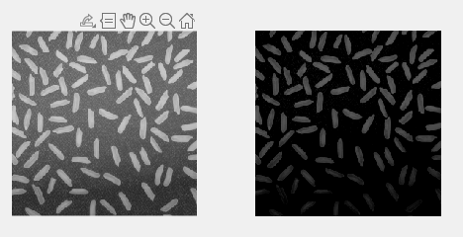

**بررسی نتیجه متلب تست 4ـ2**

clc

clear

close all

f=im2double(imread('rice.png'));

m=mean2(f);

f2=f-m;

F=fft2(f);

F(1,1)=0;

fhat=ifft2(F);

max(abs(f2(:)-fhat(:)))

%% Show results

subplot(1,2,1),imshow(f);

subplot(1,2,2),imshow(fhat);

………………………………………………………………………………………………………………………………………………………………………………………………………………………………………………………………………………………………………………………………………………………………………………………………………………………………………………………………………………………………………………………………………………………………………………………………………………………………………………………………………………………………………………………………………………………………………………………………………………………………………………………………………………………………………………………………………………………………………………………………………………………………………………………………………………………………………………………………………………………………………………………………………………………………………………………………………………

